1. When any user export something to the area of concerns, then a notification will come to project control manager (this person wants to add …… to area of concern? Accept, Reject).
2. If you reject it will never be added to area of concerns.
3. If approved it will be added.
4. List page should show. (Measures Taken & Reason of concern) and remove prepared by.
5. Export To risk register should be added
6. List page – we should filter by Category

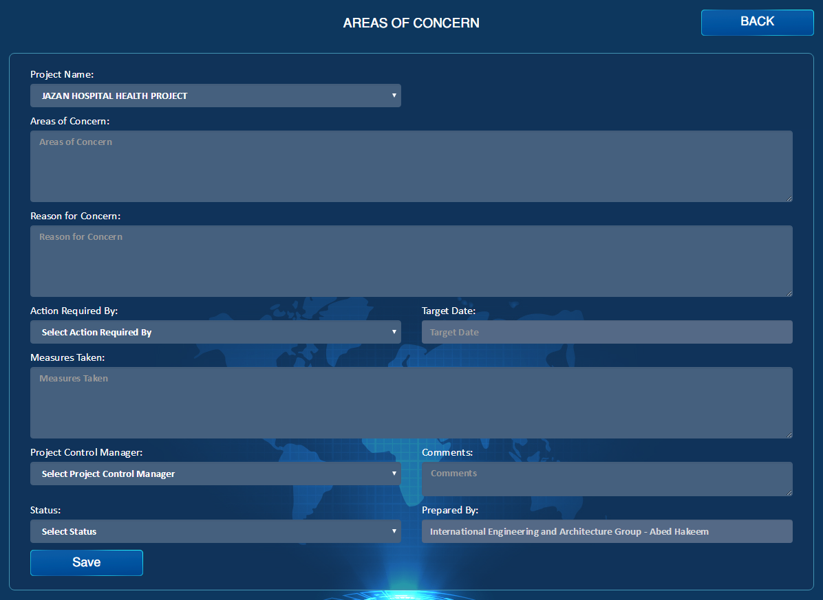

Category (dd)

Reject

Accept

Draft

Submit

Attachment

Item No.

Notes

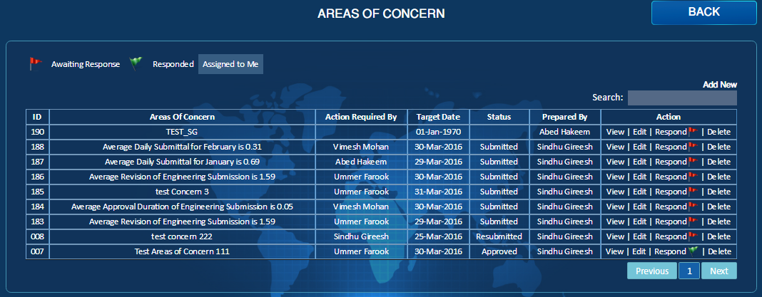

Export To Risk Register

Category (dd)

EmailPDF

PDF

No Action Required

Action Required